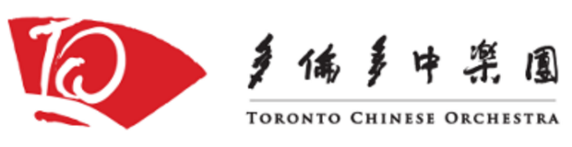
Audition Guidelines

Your audition will consist of the following:
- Prepared performance: you will be given two excerpts to prepare
- Sight reading: clap the rhythm of an unfamiliar excerpt
You will not be required to play your instrument
- Interview

Sample Excerpt for TCO Applicants (Erhu):

Sample Excerpt for TYCO or TCCO Applicants (Erhu):
Assessment Guidelines:

 | Level 3 | Level 2 | Level 1
Preparation (25%) | - Audition carefully prepared  - Plays at given speed  - Reads staff notation or prepared own jianpu | - Audition carefully prepared  - Plays somewhat below given speed  - Unable to read staff notation or did not prepare own jianpu | - Audition not well-prepared with many errors  - Plays significantly below given speed  - Unable to read staff notation or did not prepare own jianpu
Rhythm  (25%) | - Maintains steady pulse throughout  - Rhythms played flawlessly regardless of difficulty | - Pulse generally steady but occasionally wavers  - Easier rhythms correct but more difficult ones less accurate | - Non-existent or widely-fluctuating pulse  - Few rhythms are correct
Tuning  (20%) | - Tunes own instrument  - Plays in tune, regardless of key  - Plays any number of keys | - Tunes own instrument  - Plays in tune with common keys or patterns  - Plays a limited number of keys | - Cannot tune own instrument  - Serious tuning issues, even with common keys or patterns  - Plays 1 or 2 keys
Ensemble  (15%) | - Responds well to verbal directions  - Follows conductor’s gestures | - Responds well to verbal directions  - Unable to follow conductor’s gestures | - Difficulty responding to verbal directions  - Unable to follow conductor’s gestures
Musicality  (15%) | - Follows all musical directions | - Follows some musical directions | - Follows few musical directions

